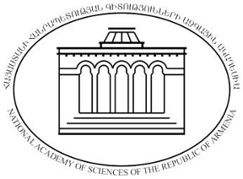 | 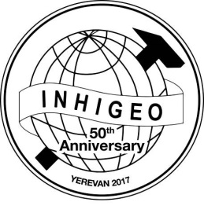 | 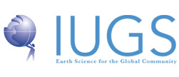 | 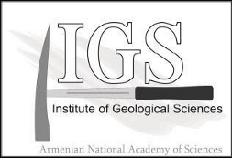
NATIONAL ACADEMY OF SCIENCES OF REPUBLIC OF ARMENIA
INSTITUTE OF GEOLOGICAL SCIENCES

42nd INTERNATIONAL COMMISSION ON THE HISTORY OF GEOLOGICAL SCIENCES (INHIGEO) SYMPOSIUM
YEREVAN, ARMENIA, 12-18 SEPTEMBER 2017
50th Anniversary of INHIGEO (1967-2017)
Expression of interest
First Name:
Second Name:
Country:
E-mail:
Telephone:
Comments
(In Comments section please mention your preliminary interest to (I) participate in the conference, (II) to make a presentation, (III) to participate in post-conference trips and (IV) intention to attend the meeting together with an accompanying person)

Please return this form not later than December 16th, 2016, to

inhigeo2017@geology.am

