BAKI UNİVERSİTETİNİN XƏBƏRLƏRİ
№2 Təbiət elmləri seriyası 2013

551.21:552.24(55)

EAST IRAN, MIDDLE EAST: NEW TECTONIC-MAGMATIC-METALLOGENIC DATA, “HOT” TECTONICS, PROBLEMS,
INCLUSIONS, HYDROCARBONS, AND CONSTRAINTS

A.E.ROMANKO*, N.A.IMAMVERDIYEV**, V.Yu.PROKOFIEV***,
I.V.VIKENTIEV***, M.HEIDARI****
*Geological Institute, Academy of Sciences (RAS), Moscow, Russia,
** Baku State University, Baku, Republic of Azerbaijan
***Institute of geology of ore deposits,
Academy of Sciences (RAS), Moscow, Russia
****Department of Geology, Bu-Ali Sina University, Hamadan, Iran
a-romanko@ya.ru;
a.romanko@yahoo.com
inazim17@yahoo.com

A satisfactory tectonic-magmatic-metallogenic correlation in the East Iran, Middle East for the Alpine time was revealed in the region (mainly metallogeny – led by outstanding regional trio: Drs. E.Romanko, A.Houshmand-Zadeh, and M.A.A.Nogol Sadat). Geological northeastern zonation due to African superplume activity including probably slab delamination is revealed too. Strongly dominated rocks of calc-alkaline and shoshonite series deal with a known subduction of Arabian plate beneath the Central Iran block. Intraplate African superplume-related rocks are subalkaline – alkaline ones including Quaternary carbonatites of Hanneshin, Afghanistan. Tectonic-magmatic pair could be postulated here. General oil / hydrocarbons (HC) productivity decreasing to the north could be in an agreement with corresponding decreasing of African superplume activity too. Regional economic Cu-Au etc. metallogeny is mainly stipulated by a subduction mentioned.

Key words: East Mediterranean belt, East Iran, Middle East, magmatism, tectonics, metallogenic peculiarities, melt and fluid inclusions, northeastern tectonic-magmatic-metallogenic and oil – hydrocarbons (HC) zonation

Middle East is geologically, economically exclusively interesting region, however, very irregular studied. Great importance of its regional study is obvious. Metallogeny and geology of poorly studied East Iran close to the Alpine - Himalayan structures junction (Khain, 2001; Khain, Leonov 1988; E. Romanko et al, 1984; Houshandzadeh et al., 1986; Imamverdiyev, 2000; Stocklin et al., 1865; Milanovsky, Koronovsky, 1973 etc.) recently studied by us under the leadership of outstanding trio – known regional specialists Drs. E. Romanko, A. Houshmandzadeh, and M.A.A. Nogol Sadat. We present new data on magmatic rocks of the region studied: dominated Paleocene – Quaternary subduction-related calc-alkaline rocks (first group) and principally other subordinate rocks younger (?) - Neogene – Quaternary (?) intraplate subalkaline and rarely - alkaline ones (second group).
Rocks of the first group (subduction-related differentiated calc-alkaline rocks: basalts - dominated andesites - rhyolites, granodiorites, etc.) are the products of a large subduction of the Tethys lithosphere and Arabian plate beneath the Central Iran block or microplate (Fig. 1). This process is confirmed by the regional tectonic analysis, tomography by known J. Ritsema’s team (Bull et al., 2009 etc.) and petrology and geochemistry (Imamverdiyev, 2000; Romanko et al., 2012; etc., fig. 1). Catastrophic earthquakes of ca. 8 M and more on the Richter scale, unfortunately, are not rare here. A recent catastrophic example is the Bam earthquake in 2003.
Formation of the antipodes - intraplate K-Na midalkaline and alkaline rocks subordinate (including true carbonatites Afghanistan and Arabia), the second group rocks relate to the African superplume activuty (table 1, fig. 1). (Neogene lamproites of Algeria etc. - E. Romanko et al., 1988; Romanko et al., 2012; etc.). They are trachybasalts, hawaiites , basaltic trachyandesites, and trachyandesites on classification and discriminated digrams (fig.2) (Bogatikov et al., 1987; Luchitsky, 1985, Yarmolyuk et al., 2001 etc.).

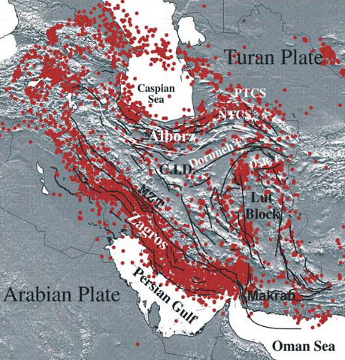
Fig. 1. Distribution of earthquake epicentres in the Middle East due to detailed work (Alinaghi et al., 2007). We can see known Lut Block and immediately next to the east studied East Iran mobile zone area (Khain, 2001, Hushmandzadeh et al., 1987, E. Romanko et al., 1984, etc.).
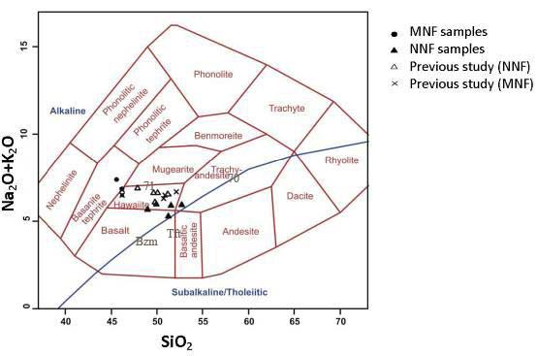

Fig.2. Total alkali, Na₂O+K₂O (wt %) versus SiO₂ (wt %) diagram for clasification of Middle East volcanic rocks (Cox et al. 1979). Tft – Taftan stratovolcano some average rocks, Bazm – Bazman stratovoclano some average rocks, 71 and 70 – intraplate rocks groups, Helman (Afghan) block, using (Saadat S, Stern C.R., 2011).

These rocks, in contrast to the calc-alkaline, characterized by an enrichment of both large-ion lithophile elements (LILE) - K, Rb, Ba, and HFSE lithophile elements - Nb, Y, Ta, Zr, Ti, P, etc. (tab.1, fig. 3) with a characteristic high Eu/Eu* - more than 1.1. Increased concentration of P₂O₅ - sometimes more than 1.0% - is a characteristic feature of the second group of rocks.
We have received fair low isotopic data ⁸⁷Sr/⁸⁶Sr (ISr) in two samples of intraplate rocks of the second type - trachyandesites R70-2 – 0.7039 ÷ 0,2 (high K/Rb=393) and trachybasalt R71-4 – 0.70489 ÷ 0,18 (K/Rb=375, fig. 4). For subduction-related calc-alkaline andesite of stratovolcano Bazman, sample R25 was determined a rather low value ISr = 0.70456 ÷ 0.05, K/Rb=250 (tab. 1). Isotopic data of these our intraplate rocks differ from collisional and subduction-related rocks from Anatolia, Turkey (Dilek et al, 2010; Khain, 2001; Imamverdiyev, 2008 etc.). Igneous rocks of the volcanic rocks are fully differentiated series of the regional known Sahand – Bazman belt. Known stratovolcanoes in this belt are: Bazman with a height 3490m and Taftan 3940m (old mark was 4042m). Old 0.7049 isotopic date for a ‘volcanite’ of an unnamed volcano in a desert was reported by Camp and Griffis in 1982 (Camp, Griffis, 1982).
Table 1
Major and trace-element composition of Middle East volcanic rocks
Component | 1 | 2 | 3 | 4 | 5 | 6 | 7 | 8 | 9
SiO₂  TiO₂  Al₂O₃  Fe₂O₃  FeO  MnO  MgO  CaO  Na₂O  K₂O  P₂O₅  Rb  Ba  Sr  Ni  Co  Cr  V  Cu  Zn  Pb  Zr  Y  Nb  Sc  Th  U  La  Ce  Nd  Sm  Eu  Gd  Tb  Er  Yb  K/Rb | 48.17  2.20  3.80  9.32  2.56  0.14  5.75  8.98  4.93  1.31  0.23  30  375  1185  86  33  64  220  63  113  5  283  25  23  19  3  1.2  44  101  -  -  -  -  -  -  -  560 | 57.80  1.31  17.48  4.37  1.07  0.09  2.27  7.10  5.11  1.42  0.61  19  293  912  53  14  60  95  65  88  20  232  19.5  17  10.7  3.65  0.99  32.4  68.3  31.4  6.00  2.11  5.08  0.78  1.64  1.26  620 | 54.50  1.87  15.94  6.39  0.40  0.09  3.37  7.58  5.81  1.73  1.05  20  -  4470  58  -  38  -  64  113  51  339  25  19  -  -  -  -  -  -  -  -  -  -  -  -  586 | 54.00  1.52  -  6.25  -  0.08  -  7.40  -  1.09  -  15  292  950  59  -  /_64  -  77  98  5  217  15  -  26.2  4.84  1.31  30  63  -  -  -  -  -  -  -  581 | 60.69  0.36  15.32  2.70  2.07  0.09  3.65  3.90  3.64  4.38  0.31  145  1230  870  50  12  50  81  69  32  20  96  15  5.8  10  12  1  18  32  -  -  -  -  -  -  -  245 | 65.39  0.42  13.71  3.25  -  0.057  1.39  2.08  2.87  4.51  0.11  117  577  232  7  5  16  63  15  40  27  158  11  8  -  -  -  -  -  -  -  -  -  -  -  -  307 | 65.10  0.51  15.54  2.42  2.32  0.13  1.72  2.80  3.36  4.59  0.20  109  1597  359  13  6  18  54  11  57  22  246  29  12  -  16.7  4.62  34.0  64.5  27  5.6  1.3  4.1  -  1.9  1.7  350 | 85.00  0.60  4.00  3.21  1.10  0.02  0.52  0.29  0.28  0.21  0.09  7  390  440  10  4  11  55  17  8  20  136  13  6  6.5  1  3  15  28  -  -  -  -  -  -  -  230 | 58.67  1.70  15.13  6.69  2.19  0.09  2.28  1.77  5.06  2.05  0.30  47  557  263  44  21  72  107  33  82  10  219  23  30  10  12  3  35.2  64.2  25.0  5.1  1.9  4.8  0.9  1.6  1.6  350

Notes. 1 and 2 - trachybasalt (sample R71-4) and trachyandesite (sample R70-2) correspondently, Haji lake, Neogene (?), Afghan block, 3 - trachyandesite, Baluchestan, Iran (Camp, Griffis, 1982), 4 - trachyandesite, R75wp, Lut block, 5 - syenite, Lar intrusiion with Cu-Au mineralization, Miocene(?) 6 – K-dacite, R75, Lut block, and 7 - trahydacite, standard, Kurama Ridge Middle Tien Shan, Karamazar, Tajikistan, Late Carboniferous - Early Permian, using data and extrapolation from (Rusinov, Kovalenker, 1991; Razdolina, Moralev et al., 1993; Mamajanov, 2005; Romanko et al., 1990) 8 - leucorhyolite, R82, east Bazman volcano, Quarternary(?), 9 - trachyandesite, continental rift, standard, Proterozoic, Pechenga area, Fennoscandian or Baltic shield, Romanko et al., 1989.
Table 2
Chemistry of melt inclusions glass (wt %) in plagioclase (1, 3), host mineral (2, 4), host acid K-volcanite (5), leucorhyolite from Bazman stratovolcano, and plagoclase standards (7-9) due to A. Betekhtin, 1953.
N | SiO₂ | TiO₂ | Al₂O₃ | FeO | MnO | MgO | CaO | Na₂O | K₂O | P₂O₅ | Cl | S | Sum
1 | 74.77 | 0.19 | 12.94 | 0.58 | 0.08 | 0.12 | 1.52 | 3.88 | 3.93 | 0.26 | 0.00 | 0.01 | 98.28
2 | 58.69 | 0.01 | 24.77 | 0.23 | 0.00 | 0.01 | 6.68 | 7.22 | 0.49 | 0.00 | 0.00 | 0.01 | 98.11
3 | 74.48 | 0.15 | 14.53 | 0.53 | 0.04 | 0.10 | 1.69 | 3.02 | 4.10 | 0.00 | 0.01 | 0.01 | 98.66
4 | 58.36 | 0.00 | 24.71 | 0.28 | 0.02 | 0.05 | 7.15 | 6.90 | 0.46 | 0.04 | 0.00 | 0.01 | 97.98
5 6  7  8 | 65.39  77.00  58.16  56.05 | 0.42  0.60  -  - | 13.71  13.00  26.57  28.01 | 2.93  3.98  -  - | 0.06  0.02  -  - | 1.39  0.52  -  - | 2.08  0.29  8.35  10.1 | 2.87  0.28  6.92  5.89 | 4.51  0.21  -  - | 0.11  0.09  -  - | -  -  -  - | - | -  -  -
9 | 62.43 | - | 23.70 | - | - | - | 5.03 | 8.84 | - | - | -

Notes. 1, 3 - melt inclusions glasses in plagioclase, 2, 4 - host minerals, 5 – host K-volcanite, 6 – leucorhyolite from stratovolcano Bazman, Quaternary(?), 7-9 plagioclase standards: 7 - andesite, SiO₂ = 58.16, empirical formula - Na_{0.6}Ca_{0.4}Al_{1.4}Si_{2.6}O₈, chemical formula andesite - (Na, Ca) (Si, Al)₄O₈, Webmineral.com, 8 - 9 - plagioclase theoretical composition: An₅₀ (8) and An₂₅ (9), by A. Betekhtin, Moscow, 1953.

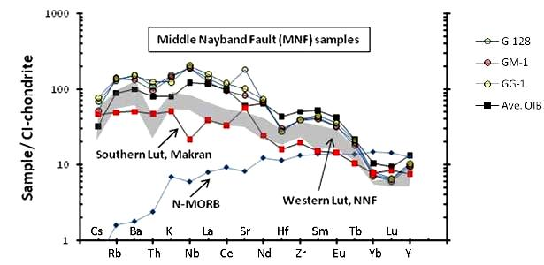
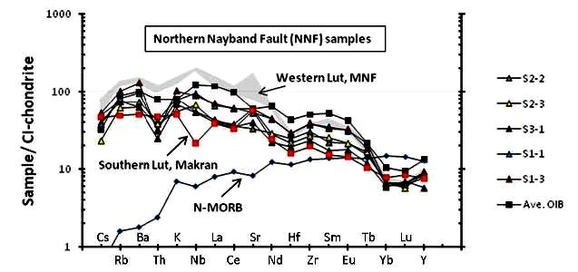

Fig.3. The distribution of the contents of rare and trace elements normalized to chondrite composition (Sun, McDonaugh, 1989), using (Saadat S, Stern C.R., 2011).
+--------------------------------------------------------------------------------------
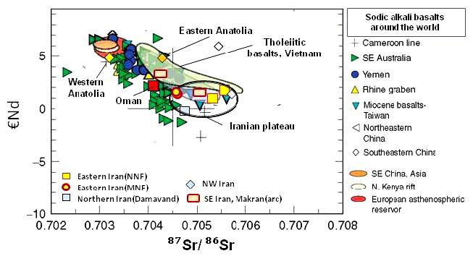

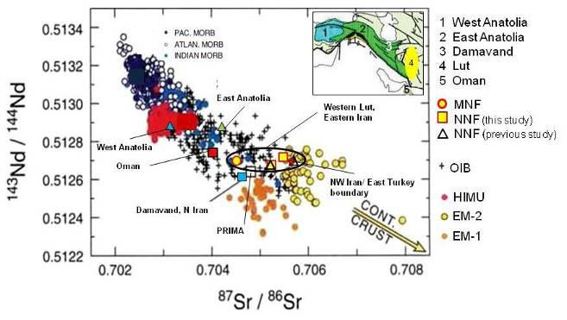

Fig. 4. Isotope systematics of igneous rocks in the region and standards using (Saadat S, Stern C.R., 2011).

Melt inclusions (as well as fluid ones – by Dr E. Romanko et al., 2000) were maybe firstly investigated in this area under the leadership of Dr. Prokofiev in the region studied. Some conclusions on this study are:
- Melt inclusions are not typical for the African super-plume-related intraplate igneous rocks due to tomography by known Ritsema’s team (Bull et al., 2009 etc).
- unusual fairly high temperature, 1150-1180º C - up to 1220º C melt inclusions were revealed in plagioclase of subduction-related K-dacite, sample 75-l by V. Prokofiev et al, 2011 (Prokofiev, 2000; Romanko et al., 2012, Fig. 5 and 6, Table 2.). This fairly deep, non-calc-alkaline rock was also affected by indirect (?) influence of a huge African super-plume, as proposed. Homogenization occurs under High T = 1150-1220º C (for comparing, for example, T much lower for acid volcanite of Quaternary Pektusan volcano, Korea, presentation of Andreeva et al., IGEM, RAS, Moscow, 2013). A higher viscosity of a glass provides more inclusions coexistence in a sample.
Maximal concentration on fluid CH₄ and other CH-based fluid inclusions were revealed in shallow intrusions on the contact with carbonate-rich host rocks in west Taftan zone; also in important Lar syenite massif with Cu-Au (E. Romanko et al., 2000; Romanko et al, 2012, in Russian). Minimal data are in Cretaceous ophiolitic mainly melange rocks.
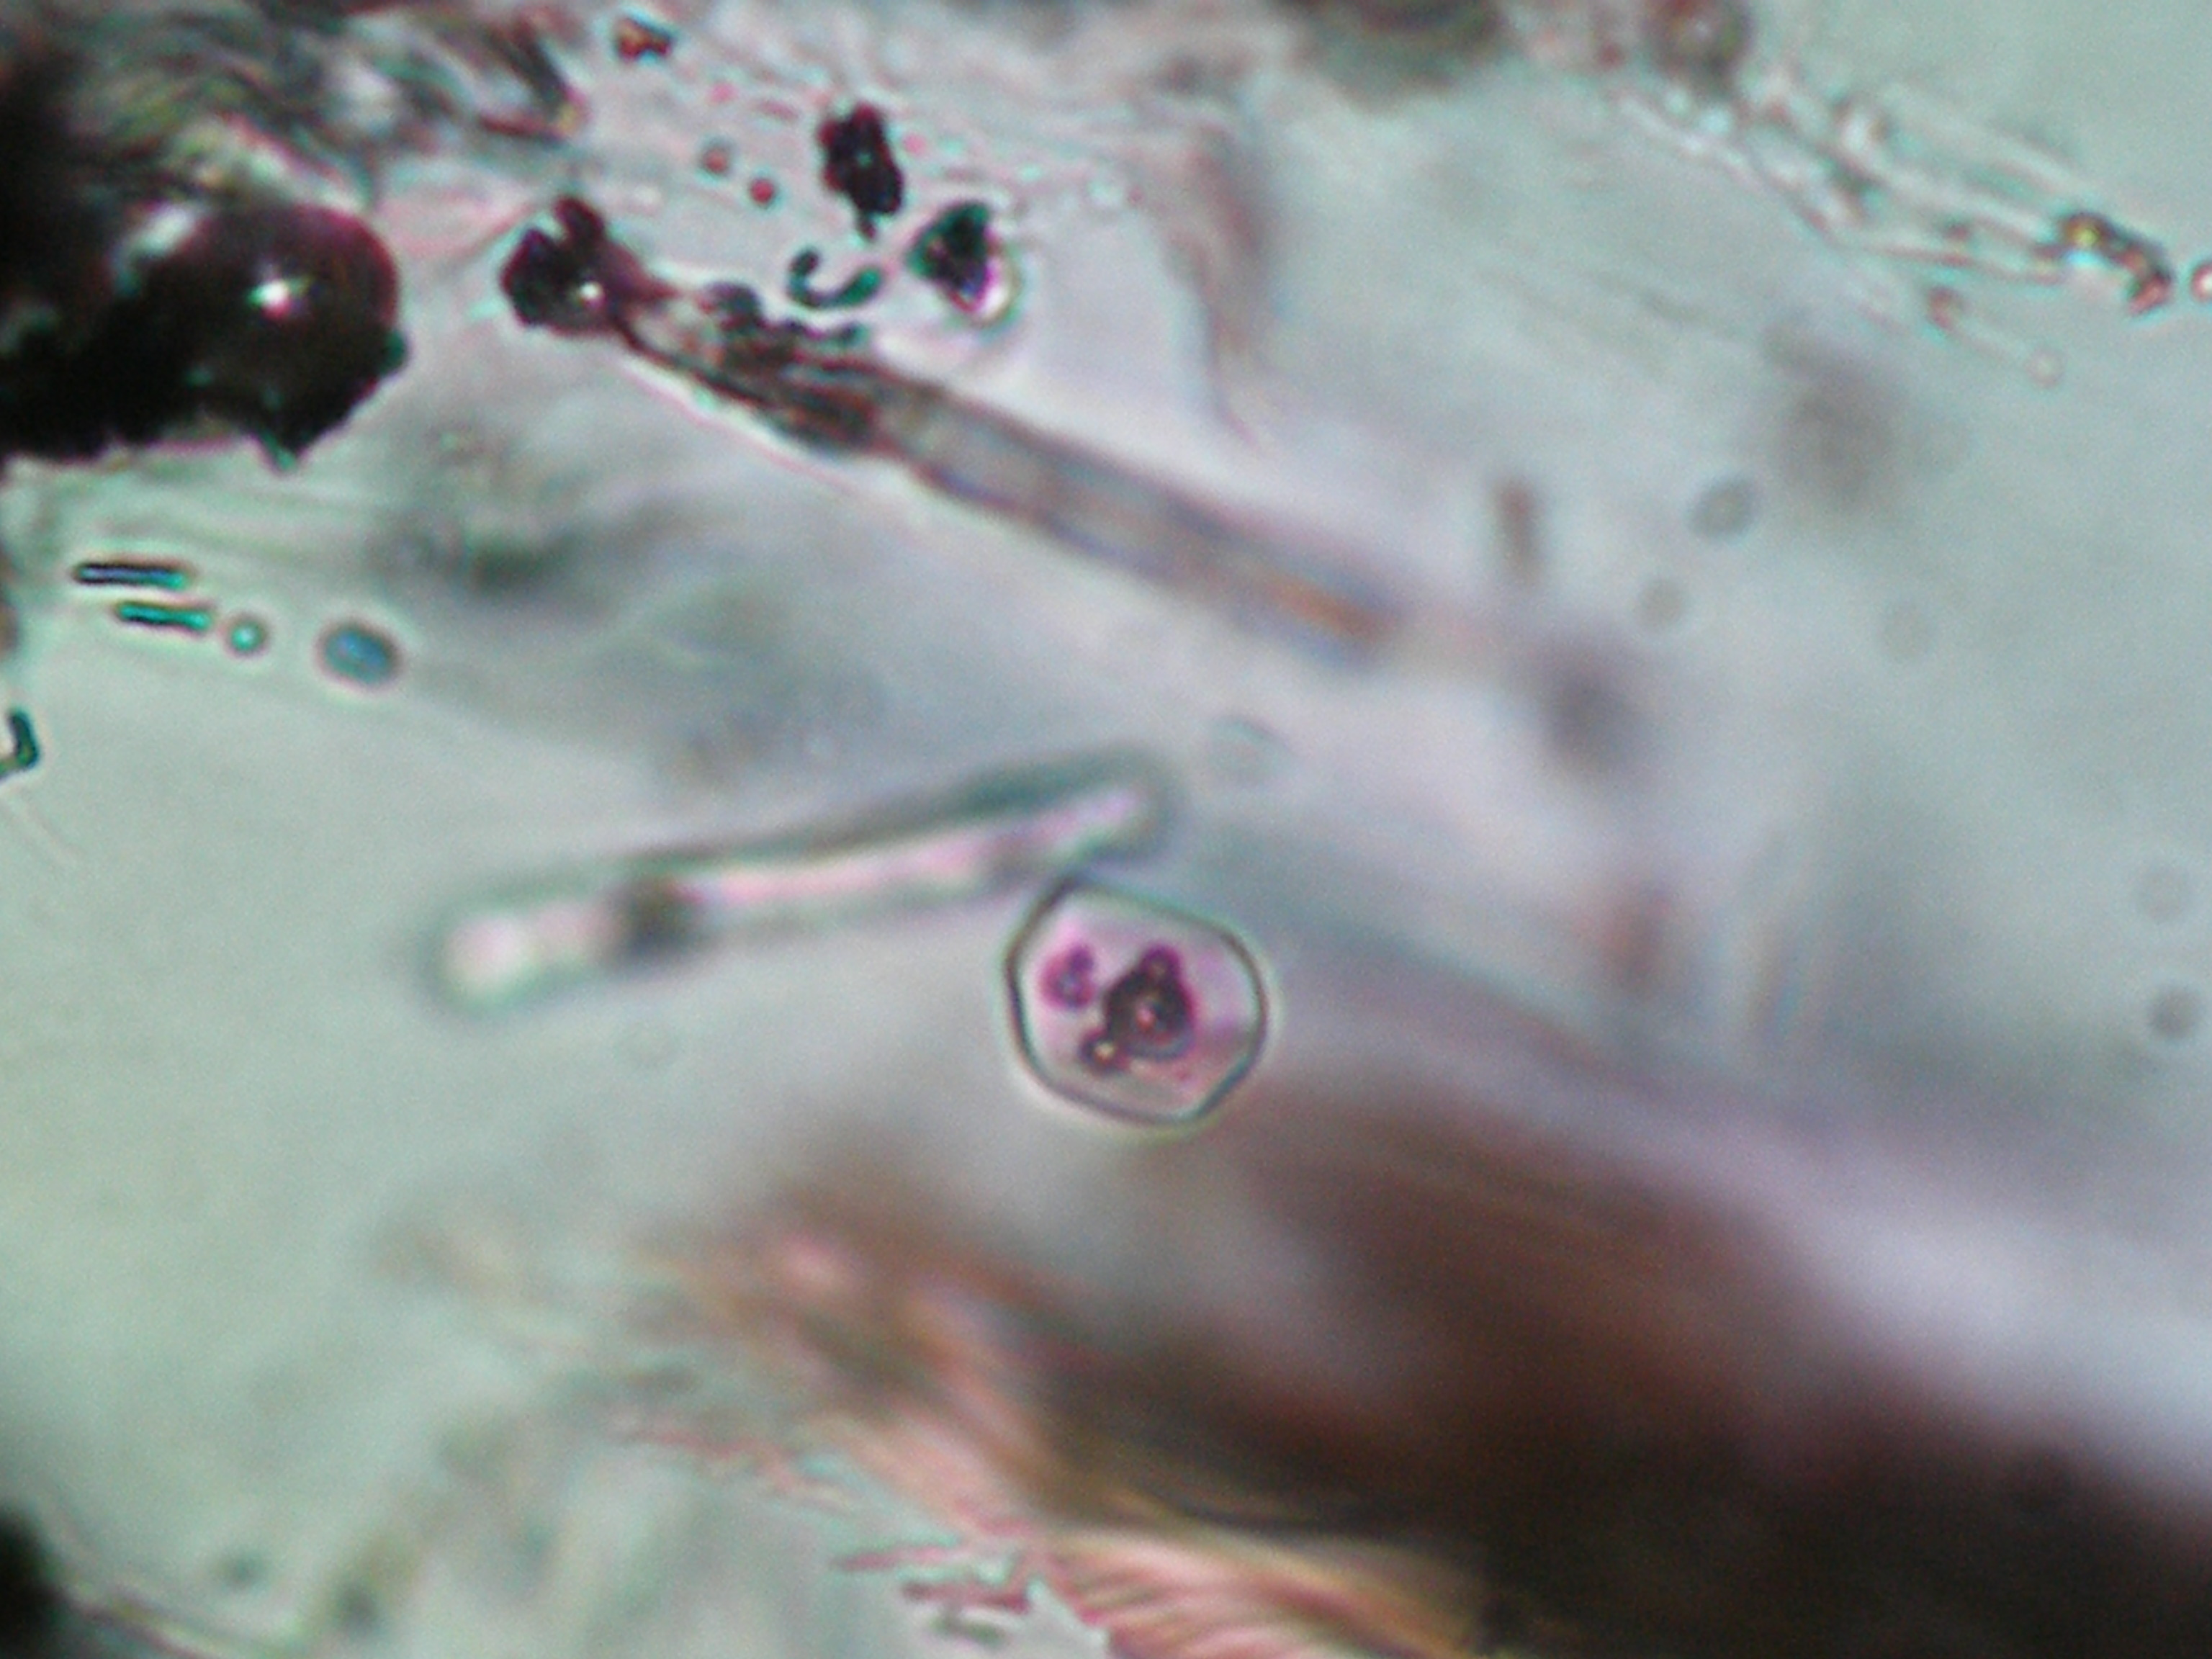

Fig.5. T=1150ºC. View of melt inclusions in acid glass from plagioclase

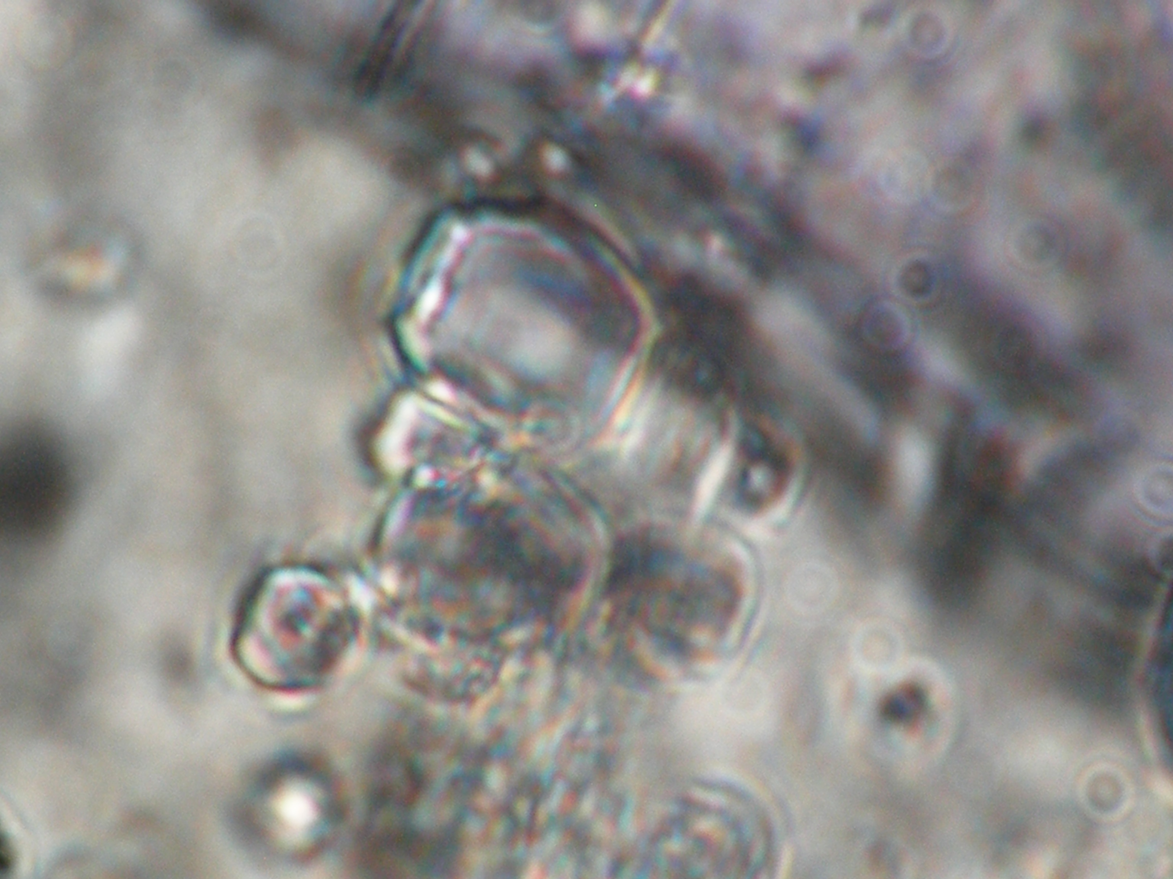
Fig. 6. T=1220ºC. Homogenization.

Second group rocks are from deeper mantle source versus those of the first group. This is supported by the following:
- Geological and petrographic and mineralogical data;
- The general style of petrology and geochemistry of these rocks, the rocks are not contrary to other regions, plume-related magmatism;
- Demonstration geochemical relationships, for example, the stable high K/Rb = 560-586-620.
The region is expected to at least partial compensation for the pre-emptive tectonic compression (with display calc-alkaline magmatism) – stretching from the corresponding intraplate magmatism. The latter, according to the imaging may be associated with the tail of the most powerful African superplume [2 and others]. Perhaps, there is also discussion in modeling - the partial screening of the plume push up plate, which is not an obstacle - it is known that the plate moves up does not stop the movement of the tail superplume laterally, as perhaps in this case.

Metallogenic questions
Calc-alkaline intrusive, extrusive, pyroclastic and volcanogenic-sedimentary rocks of the first group are characterized by a common copper-gold metallogenic profile for the province, matching belt metallogeny mentioned Sahand - Bazman whole country. The overwhelming majority of occurrences the study area is associated with magmatic complexes. Dr. Eugene Romanko has revealed such metallogenic types here as:
- Multi-sulfide (Au-Mo-Cu-Pb-Zn) subvolcanic porphyry type;
- Au-As-Hg-W-Mo-volcanic exhalation one;
-Low-sulfide gold-silver plutonic one;
-Gold-copper (Au-Cu) skarn and plutonic-hydrothermal one (E. Romanko et al., 2000) using also known data on other mineralization (Prokofiev et al., 2000; Vikentiev et al., 2004 etc.);
-Sulfide, sulfur, alunite exhalation, surface one;
-Native-copper-sulphide volcanogenic one with zeolites;
-Silver volcanogenic sulphide (+ gold?) one.
Thus, intraplate rocks are strongly specialized in REE, P (usual process), then in Sr, Ba, U, Th due to nowdays materilas. So, tectonic-magmatic, and as revealed E.Romanko – metallogenic zonation in the region was revealed in the region studied (at least in the Central – East Iran). Younger magmatic products are in the northeast of region due to lithosphere subduction and decreasing of Afrocan superplume activity in the same direction. Subduction-related (1 group of rocks) dominated calc-alkaline rocks and shoshonites-latites. , and, intraplate African superplume-related (Laverov et al., 2004; Yarmolyuk, personal communication, 2012, etc.) midalkaline – alkaline rocks including known Pleistocene carbonatites of Hanneshin, Afghanistan and, also, of one of Arabia are subordinated (2 group of rocks). Rocks of 1 and 2 groups are interpreted by us as a tectonic-magmatic couple due to one from physics etc. In this case, at least, partial compensation of subduction compression by the intraplate extension is possible. The presence of the mentioned Cenozoic intraplate carbonatite-derived depth of the melt - an argument in favor of the African superplume influence on the magma plume of a large region, which is in agreement with effective tomography of the well-known J. Ritsema’s team (Bull et al., 2009). Also, There are materials about of oil/HC productivity decreasing in the direction mentioned as stressed known V. Khain with co-authors in the Explanatory map of Caspian Sea region scale 2: 2 500 000, from the extremely rich Persian Gulf to South – Middle – North Caspian Sea region, which in agreement with the increasing distance from the African superplume, within the known hydrocarbon belt as noted by a famous tectonist V. Khain (Khain, 2001 etc.; Romanko et al., 2012; etc.). More specifically, this HC global (?) belt is the Persian Gulf – Russian Arctic coast one due to old Russian maps, ex, USSR oil structures map scale 1:2 500 000 etc. HC productivity decreasing is in agreement with the increasing distance from the African superplume as seen by a tomography mentioned above. Also, salt domes are oriented due to northeast direction with respect to African superplume in the east Persian Gulf. More HC data needed, surely.

Conclusions
1. Northeast tectonic-magmatic zonation and partly – metallogenic one (last one by E. Romanko) in the region studied was revealed. It caused maybe directly by known Arabian plate subduction under the Central Iran. But African superplume controls magmatism, hot regional tectonic regime, and maybe even all geology including Jurassic Karoo flood basalts event, then Paleogene magmatism in the East Africa and Paleogene subduction, 11-9 Ma opening of Red Sea etc., maybe delamination of a slab in East Mediterranean (Khain, 2001; Imamvediyev, 2007, Romanko et al., 2012 etc.).
2. Two different types of Cenozoic magmatic rocks (antipodes) were revealed. Dominated Oligocene-Recent calc-alkaline and midalkaline - alkaline Neogene-Quaternary ones. First, the calc-alkaline subduction geodynamic setting are responsible, and second - intraplate. Energetically favorable tectonic-magmatic pair with these types of rocks exists. Igneous rocks of the second group are generated deeper in comparison with the first group rocks, although sudden high/very high (?) temperature on melt inclusions in High-K subduction-related rocks were firstly received by known specialist V.Prokofiev (Prokofiev, 2000; Prokofiev et al., 2007, Romanko et al., 2012).
3. Calc-alkaline rocks are characterized by an economic copper-gold+-silver (Cu-Au+-Ag) regional subduction-related mineralization with a subordinate different mineralization (Au-Ag low-sulphide, Ag-sulfide with Au (?) etc.). Intraplate rocks bear REE, P, also Sr, Ba, Th, and U mineralization due to our data.
4. Deep processes - versus upper crustal ones - mainly control magmatism, tectonics and then metallogeny in the region studied. Hot tectonic regional regime is controlled mainly by African suprplume activity. Paleogene (Pg) Cu-Au regional mineralization is in a good agreement with a regional subduction.
We are extremely grateful to outstanding regional trio - Drs. E.Romanko, A.Houshmandzadeh, and M.A.A.Nogol Sadat for their management in field works and comprehensive care, in addition – V.V.Slavinsky (consulting and ctiticism), A.Savichev and S.Stepanov, B.Zolotarev and V. Lyakhovich, V.Yarmolyuk, V.Trifonov, G.Karpova, M.Buyakayte, V.Petrova, I.Gablina, Yu. Malinovsky, S.Palandzhyan and G.Nekrasov, A.Shchipansky, G.Makarychev, V.Rusinov, V. Kovalenko, I.Kravchenko, A.Girnis, A.Pertsev, A.Mokhov, V.Volkov, N.Tarasov, S.Bubnov, G. Moralev; also to A. Meskhi from Kazan, Russia, and more other different specialist for long discussions, different advices, analytical support etc.
This work was supported by the RF Basic Research, project 03-05-64805.

REFERENCES
- Abdullah S., Chmyrev V., Dronov V., Ed., 1980. Geology and Mineral Resources of Afghanistan. Moscow: Nedra. Book 1, p. 535, Book 2, p.336 (in Russian).
- Alinaghi A., Koulakov I., Thybo H., 2007. Seismic tomographic imaging of P- and S-waves velocity perturbations in the upper mantle beneath Iran // Geophysical J. International, 169, pp. 1089-1102.
- Artemiev M., 1971. Some features of the deep structure of the Mediterranean type basins according to isostatic gravity anomalies // Bull. Moscow Society of Naturalists, Dept. Geol., no 4, pp. 30-41 (in Russian).
- Bogatikov O.A, Kovalenko V.I., Yarmolyuk V.V., Bubnov S.N., 1987. Series of igneous rocks: problems and solutions // Reports of the Academy of Sciences of the USSR, Series Geol, no 3, pp 3-12 (in Russian).
- Bull A.L., McNamara A.K., Ritsema J., 2009. Plume clusters and thermochemical piles // Earth Planet. Sci. Lett. Vol. 278, pp. 152–162.
- Dilek Y., Imamverdiyev N.A., Altun-kaynak Şafak, 2010. Geochemistry and tectonics of Cenozoic volcanism in the Lesser Caucasus (Azerbaijan) and the Peri-Arabian region: Collision-induced mantle dynamics and its magmatic fingerprint // International Geology Review, vol. 52, issue 4-6, pp.536-578.
- Hushmand-Zadeh A., Nabavi M.H., 1986. Metamorphic Map of Iran Scale 1: 2,500,000. Tehran: Geol. Survey. Iran.
- Imamverdiyev N.A. 2000. Geochemistry of Late Cenozoic volcanic complexes Lesser Caucasus Baku. Nafta-Press. 2000. 192 p.
- Imamverdiyev N.A. 2008. Delamination of subducted lithospheric slab as the cause of Late Cenozoic volcanism in the Lesser Caucasus // News of Baku University. Natural sciences Series. no 3, pp.536-578.
- Khain V., 2001. Tectonics of Continents and Oceans (year 2000). Moscow: Scientific World, 2001. 606 p, (in Russian).
- Koronovsky N.V., Demina L.I., 1999. Collisional stage of the Caucasian sector Alpine fold belt: geodynamics and magmatism // Geotectonics, no 2, pp. 17-35.
- Koronovsky N.V, Lomize M.G., 2006. Tectonic accretion and collision as the steps of forming inter-continental fold belts. Areas of active tectonics in modern and ancient history of the Earth / Materials 39 Tectonic meeting, vol. 1, Moscow: GEOS. pp. 353-357.
- Laverov N., Kovalenko V., Yarmolyuk V. et al., 2006. The latest volcanic activity in Northern Eurasia: Zoning and environment of formation // Russian Academy of Sciences (RAS) Reports. vol. 410. no 4, pp. 498-502 (in Russian).
- Luchitsky I.V., 1985. Palaeovolcanology. Moscow: Science (Nauka), 235 p. (in Russian).
- Milanovsky E.E., Koronovsky N.V., 1973. Orogenic volcanism and tectonics of the Alpine belt of Eurasia. Moscow: Nedra, 280 p.
- Prokofiev V.Yu., 2000. Geochemistry of ore-forming fluids of hydrothermal gold deposits of different genetic types according to the study of fluid inclusions. Moscow. Science (Nauka), Novosibirsk, 192 p.
- Prokofiev V.Yu., Bortnikov N.S., Zorina L.D., Kulikova Z. I., Matel N. L., 2000. The Darasun intrusive-related gold-base metal deposit, Eastern Transbaikalia, Russia: Petrochemical, melt and fluid inclusion, REE and stable isotope (O, C, and S) studies // Applied Mineralogy. Rammlmair et al., Eds. Balkema, Rottertdam, Brookfield, 399-402 pp.
- Romanko E., Kokorin Y.., Krivyakin B. et al., 1984. Outline of metallogeny of Anarak Area (Central Iran). Ministry of mines and metals // Geological Survey of Iran. Rep. 21, Tehran. Technoexport, 136 p.
- Romanko E., Voinkov D., Houshmandzadeh A. et al., 2000. Characteristic features of ore mineralization in the Sistan-Baluchestan Province, SE Iran: evidence from fluid inclusions data / International conference on geology of Mediterranean belt. Absracts. Beograd.
- Romanko E., Romanko A., Meskhi A., 1998. On a Geology and Geochemistry of Mesozoic-Cenozoic igneous rocks in NE Algeria // Reports of Academy of Sciences (RAS). 1998. Vol. 362, no 2, pp. 236-238 (in Russian).
- Romanko A., 2005. New data on Cenozoic subalkaline intraplate rocks the East Iran. // Reports of the Academy of Sciences (RAS), v. 404, no 4, pp. 510-513.
- Romanko A., Imamverdiyev N. A., Prokofiev V., Tabatabaeimanesh S. M., Vikentiev I., Savichev A., Stepanov S., 2012. On Cretaceous – Quaternary magmatic – tectonic - metallogenic peculiarities in Northeast Iran and South Tajikistan: new data, melt inclusions, constraints, and some problems / European Seismological Commission Assembly. ESC. Book of abstracts. M. Polygraph, pp. 154-155.
- Sandwall E., Turkell N., Zor E. et al., 2003. Shear wave splitting a young continent collision // Geophys. Res. Lett., 30. no 24 b, pp.185.-194.
- Viketyev I.V., Yudovskaya M.A., Mokhov A.V. et al. 2004. Gold and PGE in massive sulphide ores of the Uzelginsk deposit, Southern Urals, Russia // Canadian Mineralogist. v. 42, no 5, pp.651-665.
- Yarmolyuk V.V., Kovalenko V.I., Bogatikov O.A., 1990. South Baikal "hot spot" mantle and its role in the formation of the Baikal Rift region // Reports of Russian Academy of Sciences (RAS). v. 312, no 1, pp.187-191, (in Russian).

ŞƏRQİ İRAN, YAXIN ŞƏRQ: YENİ TEKTONO-MAQMATİK-METALLOGENİK MƏLUMATLAR, “QAYNAR” TEKTONİKA, PROBLEMLƏR, ƏRİNTİ VƏ MAYE DAXİLOLMALARI, KARBOHİDROGENLƏR VƏ MƏHDUDİYYƏTLƏR

A.E.ROMANKO, N.Ə.İMAMVERDİYEV, V.YU.PROKOFYEV,
İ.V.VİKENTYEV, M.HEYDARİ

XÜLASƏ

Şərqi İran (Belucistanın qərbi və ya Seystan və Belucistan əyaləti) və Yaxın Şərq üçün alp dövrü üçün kifayət dərəcədə tam tektono-maqmatik korrelyasiya (metallogeniya –məşhur regional trio – elmlər doktorları E.Romanko, A.Xuşmanzadə və M.A.A.Naqolya Sadat tərəfindən) müəyyən edilmişdir. Afrika superplyüminin fəaliyyəti nəticəsində “qaynar” tektonika və şimal-şərq istiqamətli ümumi geoloji zonallıq müəyyən edilmişdir və regionda delaminasiya və ya plitənin və ya slebin ayrılması prosesi ilə izah edilə bilinər. Regionda üstünlük təşkil edən əhəngli-qələvili və az miqdarda şoşonit-latit seriyası Ərəbistan plitəsinin Mərkəzi İran blokunun altına subduksiyası ilə izah edilir. Xanneşin və Əfqanıstanın karbonatitləri də daxil olmaqla mülayim qələvili və qələvi seriyanın süxurları Afrika superplyüminin birbaşa funksiyası ilə əlaqədardır. Tektono-maqmatik cütlüyünü burada postulat kimi qəbul etmək olar. Şimal rumbunda karbohidrogenlərin məhsuldarlığının ümumi azalması fikri də bu istiqamətdə göstərilən superplyümin azalmasına zidd deyildir. Regiondakı regional sənaye tipli mis-qəzəl və b. minerallaşması göstərilən subduksiya ilə izah edilir.

Açar sözlər: Aralıq dənizi qurşağının şərqi, Şərqi İran, Yaxın Şərq, maqamtizm, tektonika, metallogenik xüsusiyyətlər, ərinti və flyüd daxilolmaları, şimal-şərqi tektono-maqamtik – metallogenik və karbohidrogen (HC) zonallığı.

ВОСТОЧНЫЙ ИРАН, БЛИЖНИЙ ВОСТОК: НОВЫЕ ТЕКТОНО-МАГМАТИЧЕСКИЕ-МЕТАЛЛОГЕНИЧЕСКИЕ ДАННЫЕ, “ГОРЯЧАЯ”
ТЕКТОНИКА, ПРОБЛЕМЫ, РАСПЛАВНЫЕ И ЖИДКИЕ ВКЛЮЧЕНИЯ,
УГЛЕВОДОРОДЫ И ОГРАНИЧЕНИЯ

А.Е.РОМАНЬКО, Н.А.ИМАМВЕРДИЕВ, В.Ю.ПРОКОФЬЕВ, И.В.ВИКЕНТЬЕВ, М.ХЕЙДАРИ

РЕЗЮМЕ

Выявлена вполне удовлетворительная тектоно-магматическая-металлогеническая корреляция на востоке Ирана (запад Белуджистана или провинция Сейстан и Белуджистан), Ближнего Востока для альпийского времени (металлогения – под руководством выдающегося регионального трио – докторов Е.Романько, А.Хушман-Заде и М.А.А.Ноголя Садата). Установлена северо-восточная общегеологическая зональность и «горячая» тектоника, коррелируемая с деятельностью Африканского суперплюма, объясняющая, по-видимому, и принципиальную деламинацию или отрыв плиты или слэба в регионе. Доминирующие в регионе породы известково-щелочной серии и, в меньшей степени, шошонит-латитовой серии, обусловлены субдукцией Арабской плиты под Центрально-Иранский блок. Внутриплитные породы повышенной щелочности и щелочной серий, включая карбонатиты Ханнешин, Афганистан и др. непосредственно связаны с функционированием Африканского суперплюма. Тектоно-магматическая пара постулируется здесь. Предположительное общее снижение продуктивности углеводородов в северных румбах также не противоречит снижению мощности указанного суперплюма в этом направлении. Региональная промышленная медно-золотая и др. минерализация региона объяснима преимущественно упомянутой субдукцией.

Ключевые слова: Восток Средиземноморского пояса, Восточный Иран, Ближний Восток, магматизм, тектоника, металлогенические особенности, расплавные и флюидные включения, северо-восточная тектоно-магматическая-металлогеническая и углеводородная (УВ) зональность.

Redaksiyaya daxil oldu: 04.06.2013-cü il.
Çapa imzalandı: 02.07.2013-cü il.

